The Roman Conquest of Italy

The Consolidation of Latium
With the expulsion of the Etruscan kings and the establishment of the Republican system firmly rooted, Rome soon turned its attention to regional dominance and expansion. Rome inherited leadership from the Etruscans and was already the dominant player in the Latium region by 509 BC.
A treaty with Carthage at this time essentially recognized Roman authority and influence over the other Latin states. These city states had formed an alliance called the Latin League, intended to provide enough mutual strength and unity of interests to treat with Rome as equals.
There is some conflicting evidence on Roman inclusion within this league, but there is no doubt that within these formative stages, they were mostly at odds.
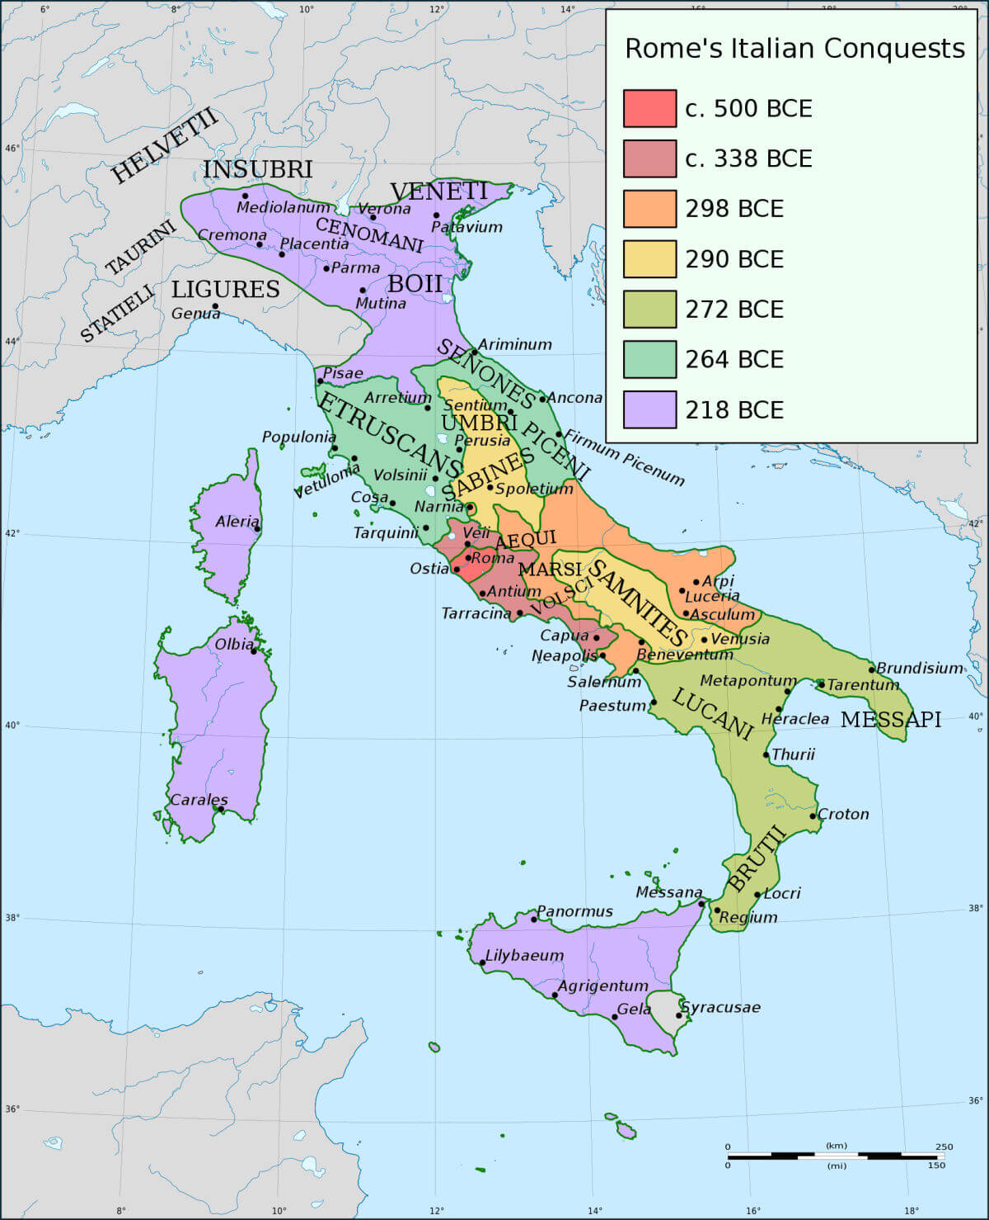
Rome's Italian expansion from c. 500 - 218 BC

From the early sixth century BC onwards, the Latin League was a cooperation of states sharing common interests, such as religious worship and defense of the region from invasion. Latium was fertile, wealthy and had access to the sea, and was therefore an inviting target to enemies such as the Etruscans, Volscians, and the Aequians.
The cities of the Latin League shared commercial treaties and provided rights of commerce, intermarriage and settlement to its citizens. It was these rights that formed the basic of the Latin rights that were to play such an important role in later Roman politics and treaties.
When Etruscan rule over Rome, and the other states in Latium, was broken, the League vied with each other for dominance. The balance of power shifted often between Rome and other influential cities like Alba Longa and Lavinium.
By 496 BC, these power gambits turned to war when Lavinium broke its alliance with Rome in an attempt to assume power. Members of the League united with Lavinium, and moved against Rome. At the battle of Lake Regillus, Rome claimed victory over the combined might of her neighbors.
Whether this victory was outright or, for all intents and purposes, a stalemate, its significance was that it proved Rome's ability to stand against the combined might of her neighbors.
Within a few years, in 493 BC, the war drew to a close, with the Latin League claiming independence from Rome. The Foedus Cassianum (Treaty of Cassius) ensured this independence, but placed Rome virtually on equal status with all the members of the Latin League combined.
Alliances continued to form and shift over the next century but external pressures, mainly from the Umbrians (Volsci and Aequi) and Sabines, forced Rome's immediate neighbors into closer ties. These alliances essentially eliminated this sense of independence, and would eventually lead to the absorption of cities and people into the Roman sphere of influence.
The 5th century BC was a time of nearly constant expansion among the Oscan-Umbrian hill peoples. One of these tribes, the Hernicii, was highly adapted to Latin culture and customs. With the pressure from the Aequi and Volsci, the Hernici joined the mutual protection treaty between the Romans and Latins in 486 BC.
The armies defending Latium consisted of Romans, Latins and Hernici. As time passed and the alliance grew more essential to survival, the Hernici were soon absorbed into the Latin culture and, as a result, little is known of them. At this time, virtually every year was wrought with conflicts.
To the east of Latium, the Latin towns of Tibur and Praeneste were threatened by the Aequi. The Aequi were responsible for numerous raids and attacks, including purportedly reaching the gates of Rome on several occasions.
Details of this time period are sketchy at best, and we rely on the often not so reliable reports of the ancients (Livy, for example). These towns disappear from recorded history about this time, and it can be assumed that the invasions were responsible.
In 458 BC, a Roman army was supposedly eliminated at the Agidus Pass, which leads into Latium east of Tusculum. In response, Lucius Quinctius Cincinnatus was appointed Dictator, and is said to have won a decisive victory over the Aequi. The Aequi, however, were not so easily defeated, and were back waging war within a couple of years.
At this time, the Volsci were in control of much of southern Latium (Cora, Velitrae, Satricum, Antium), and pressured the Latins from there. Under the leadership of the legendary Roman renegade Coriolanus, they - much like the Aequi were said to have - reached Rome itself.
The decisive battle between the Latins and these Umbrian invaders appears to have been fought in 431 BC. The Romans, under the command of Aulus Postumius Tubertus, again met the Aequi at the Algidus Pass, but this time were victorious.
With this victory, the Romans opened an aggressive offensive which the Umbrian tribe were unable to withstand forever. By the 390s BC, the Romans and Latins had regained control of the plains and relegated the Aequi and Volsci to the western highlands. The Volsci were finally defeated with the capture of the port of Antium in 377 BC. The Aequi seem to be eliminated from history as a separate entity within this same timeframe.
To the northeast of Rome, the territory between the Tiber River and Anio River was constantly pressured by the Sabines. Historical accounts of the Roman relationship with these people are mixed. A Sabine invasion is said to have seized Rome in 460 BC, but, after a major victory for Rome in 449 BC, the Sabines fall from the annals of history for nearly two centuries. They, like other neighbors, were eventually absorbed into Roman culture, and became a part of the growing city.
As an example, one such Sabine group zealously allied with Rome. In contrast to their invading cousins, and during open conflict, they sought and gained permission to move their entire populace onto Roman territory and become Romans. Among these immigrants were the Attus Clausus, later the Roman Gens Claudian, which evolved into one of Rome's elite and highly influential families.
As stated previously, with the victory over the Umbrians, the military policy of Rome became more aggressive in the years between 449 and 390 BC. The Etruscans, especially the city of Veii, remained a constant source of strife.
By 396 BC, in large part thanks to Gallic invasions, the Etruscans were weak and the door to their conquest was opened. But the Gauls were on the move from the north, and disastrous conflict would be in store. Further Roman expansion to the south was to be met by the Samnites in a series of several wars.
In the 300 years or so since her founding, Rome had yet to firmly secure her own region of Latium, and still faced considerable challenges ahead.

Roman Conquest of Italy - Table of Contents
- Veii and the Etruscans
- The Gallic Sack of Rome
- The Samnite Wars
- The Latin Revolt and the End of the Latin League
- The Pyrrhic War
- Veii and the Etruscans
- Share
- Tweet
- Share
- Pin
- Share
- Despite removing the yoke of Etruscan rule in the late 6th century BC, the Etruscans would remain a viable threat to the fledgling Roman Republic for another three centuries. The Etruscan city-state of Veii was situated only 12 miles to the north of Rome and, being equally matched in strength, was the main source of concern.
- 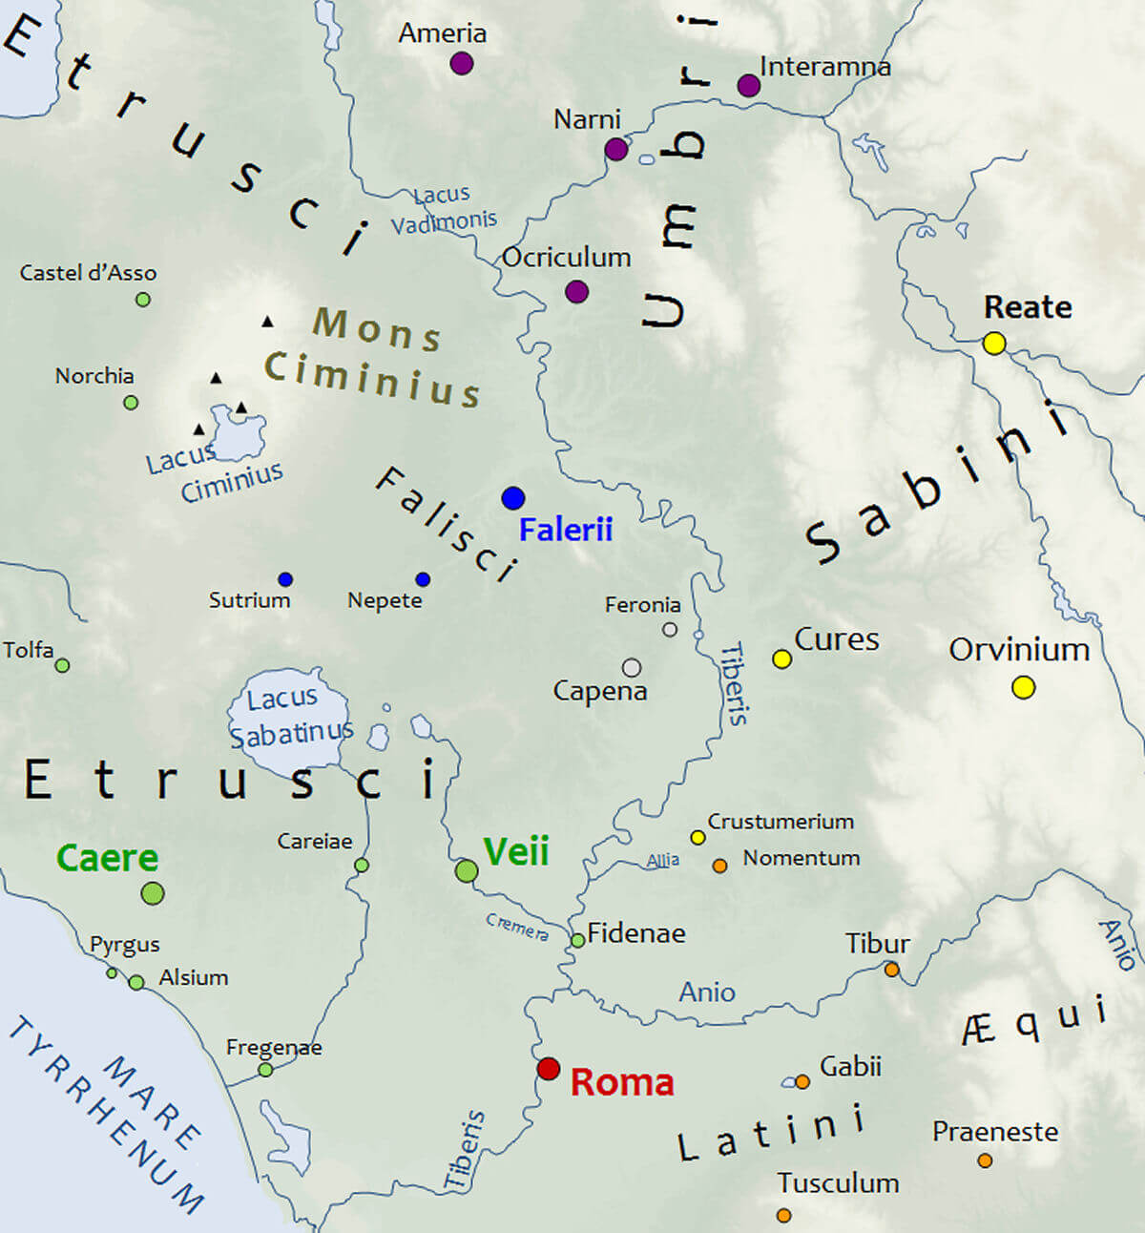
ColdEel & Ahenobarbus, CC BY-SA 3.0, via Wikimedia Commons
- A map showing Veii, Rome and the surrounding region in 450 BC

- Between Rome and Veii ran the important transportation and commerce artery, the Tiber River. Control of it was vital to both cities, and conflict was inevitable. The city controlling access to the Tiber also controlled access to Western Italy, Latium, Samnium, Etruria, and partly northern Campania. The town of Ostia, settled on the mouth of the Tiber and the Mare Tyrrhenum, was also a vital source of salt, and access to its mines were of utmost importance to both cities.
- Such vital economic repercussions in a considerably small area led to many conflicts over time. As such, in the early 5th century BC, a powerful Roman familia, the Fabians, had settled into Etruscan territory near the town of Fidenae. With the risk of potential damage to the Etruscan economy, raids on both sides soon escalated led to war.
- While the history of the events that followed is based on legend (and suspiciously similar to the Peloponnesian battle of Thermopylae), it was said that the Veientanes destroyed 300 Fabii at the Battle of the Cremera, leaving all but one dead.
- Within a year of the victory at the Cremera, the Etruscan navy - in conflict with Greece - was destroyed by Hieron of Syracuse, off of Cumae. The result was a military disaster for the Etruscans that they never really seemed to recover from. The various city states of the Etruscan league, including Veii, devolved more and more into separate unrelated entities, thereby losing the strength of mutual protection. Veii, despite its recent upper hand at Cremera, was forced to make a treaty with Rome.
- Within this timeframe, a more consequential series of events were taking place, however. Celtic Gauls had been migrating into northern Italy from the 6th century BC, and establishing themselves at or near Etruscan territory. Raids and warfare with these people would have a debilitating effect on the Etruscans, and play directly into the growing strength of Rome. The Gauls so weakened the Etruscans that the Romans, between 406 and 396 BC, went on the offensive.
- It's around this period in history that Livy tells us of the legendary Roman hero Marcus Furius Camillus. Under his command, Fidemae was retaken from Veii, and then the city of Veii itself came under siege. According to the legend, the Siege of Veii lasted 10 years, but its description is so closely paralleled to the Homeric Siege of Troy, that we must take into account the propaganda used by ancient sources to inflate the glory of Rome.
- The actual siege probably lasted considerably less time, though the introduction of a paid professional legion during this course of events indicates that it was a protracted campaign. The siege was finally broken, in 396 BC, when the Romans supposedly drained Alban Lake. This would not only divert water supplies from the city, but allowed access for Roman soldiers to sneak under the walls through the empty stream beds.
- In the end, whatever the truth behind the legend may be, Camillus was credited with saving Rome, and bestowed with the unending admiration of the Romans throughout their history.
- Gaining Veii, the Romans - in stark contrast to their general conquest policies of incorporation - destroyed much of the city and drove out many of the Etruscan residents. The territory was allotted to Roman citizens, and four new tribes were created: the Stellatine, Tromentina, Sabatina and Aniensis.
- Veii's capture resulted in a considerable increase in Roman territory and strength. As a result, the Roman state - which had already been a match for the Latin league in its entirety - was now greatly predominant in resources and manpower over her divided neighbors.
- Slowly, over the course of the next century, the Etruscan cities would be added to the Roman fold one by one. In various forms over this time, they would side with Rome's enemies in desperate attempts to break their hold on power in central Italy.
- The decline of the Etruscan people, however, with regards to their power in the region, was inevitable by this point. Their lack of unity and cooperation, despite joining various enemies of Rome in the waning years of Italian independence, led directly to their own demise. By 273 BC, Etruria and the Etruscans would be completely within the domain of Rome.

- The Gallic Sack of Rome
- Share
- Tweet
- Share
- Pin
- Share
- In the 5th and early 4th centuries BC, migratory Germanic tribes pressured Gallic Celts living in the Danube regions to push south in search of new territory. They were likely familiar with the Po River valley, in north-central Italy, from trade arrangements with Etruscans who were there.
- The Gauls crossed the Alps en masse, capturing and settling Etruscan territory by force. The Gallic tribes were united only by blood and origin, and each maintained their own kings or warlords. Some of these tribes settled into cattle and cereal farming, along with peaceful cohabitation, but others maintained aggressive policies towards their new neighbors.
- One such tribe, the Senones, was under the command of a Brennus, who led his Celts to the Etruscan city of Clusium, about 100 miles north of Rome. It is important to note that much of the ancient source material, such as Livy, Polybius and Diodorus Siculus, is steeped in legend or, especially on the part of Livy, biased though nationalism.
- 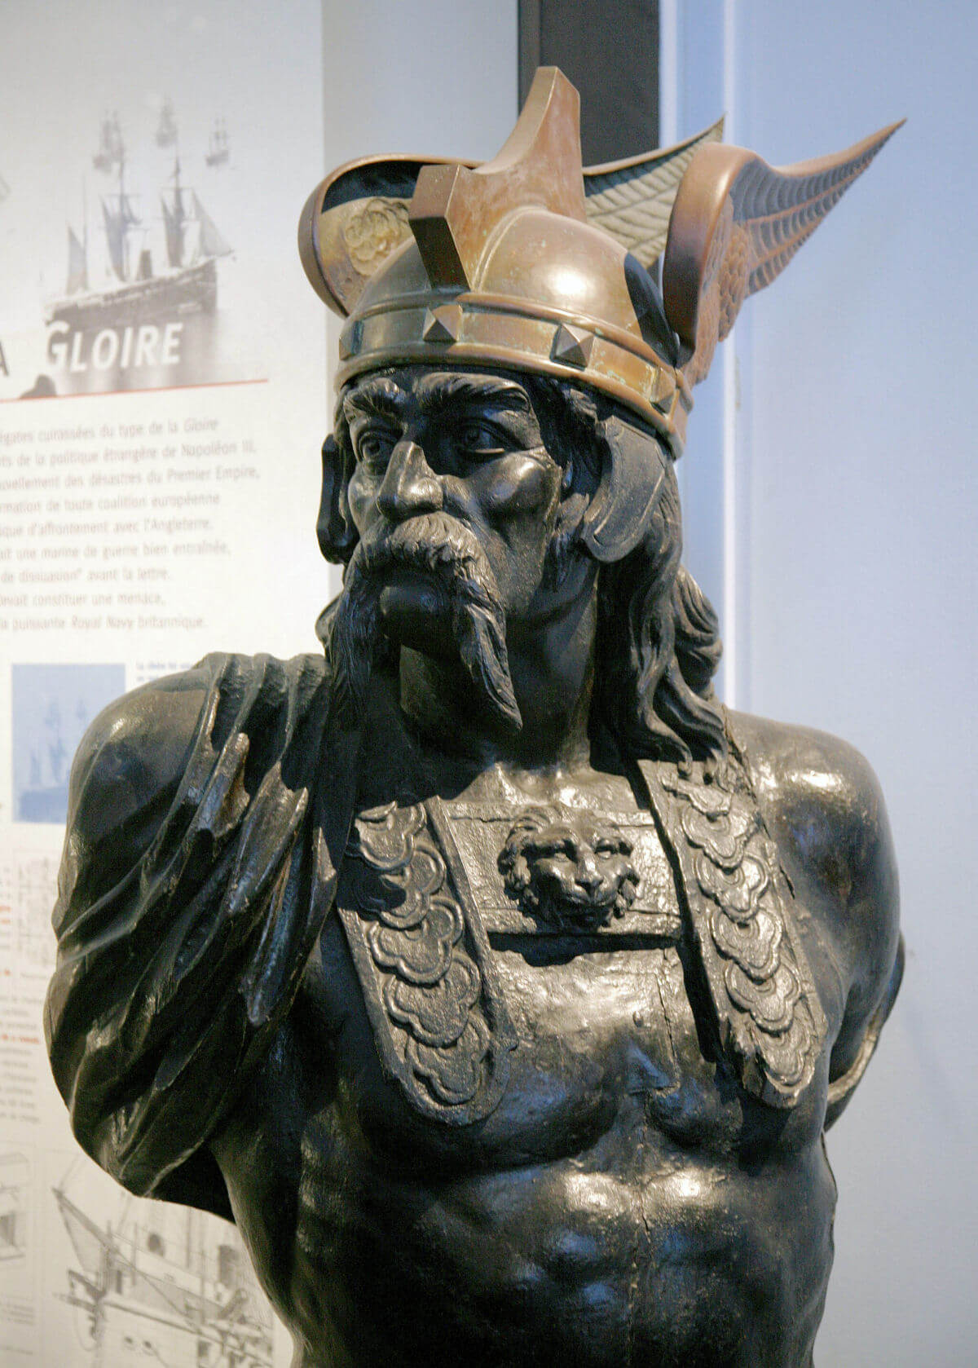
- Brennus, leader of the Senones

- Whether Clusium was the target, or it simply stood in the path on the way to the more powerful city of Rome, is unclear. What is certain, however, is that the Celts did approach and lay siege to Clusium, and that the Etruscans there likely set aside any differences and called to Rome for help.
- In response, according to the ancients, the Romans sent a delegation of three envoys to treat with Brennus. Siculus claims that the three were really spies sent to assess the strength of the Celts, but it is apparent that whatever the reason for the meeting, it escalated into violence.
- After exchanging insults, the Roman envoys were involved in a skirmish with the Gauls, in which one Celtic chieftan was killed. The commissioners returned to Rome without relief for Clusium, and with an angry Gallic army behind them. Brennus sent his own representatives to Rome to demand the three men be turned over to him, but was predictably refused. Later that year, the angered Gauls left Clusium behind and headed for Rome to seek revenge.
- The advancing Gauls invaded Roman territory and threatened the security of Rome itself. Eleven miles to the north of Rome, an outnumbered Roman army mustered under the command of Quintus Sulpicius. The two armies met in July of 387 BC (the traditional date is recorded as 390 BC, but the Varronian chronology is erroneous), and suffered a crushing defeat on the banks of the River Allia.
- As all appeared lost, some Roman defenders retreated to the Capitoline Hill to endure a siege, while civilians fled through the city gates to the city of Veii and the surrounding countryside.
- The Gauls poured into Rome, slaughtering civilians, while looting and burning everything in their path. At some point they apparently attempted an uphill attack on the heavily fortified capital, but were repulsed and never able to dislodge the occupants.
- For seven months the Gauls remained in the area and wreaked havoc around Rome. Several assaults on the city all failed, and one such night attempt was even said to have been thwarted through the timely intervention of the sacred geese of the Temple of Juno, who made a noise when disturbed by the approaching Gauls.
- In any event, by this point the Roman garrison must have been getting dangerously low on supplies. The Romans engaged with Brennus for terms that would ensure that the Celts depart, and Brennus apparently agreed to leave Rome for the price of 1,000 lbs. of gold.
- There are theories that many of the Gauls were becoming ill from from disease, or that their own settlements to the north were under attack by other tribes. Whatever the reason, Brennus agreed to leave when the Romans had accepted the terms. The following passage from Livy, regarding these terms, leaves us with one of the most famous lines accredited to a barbarian chief in dealings with Rome:
"Quintus Sulpicius conferred with the Gallic chieftain Brennus and together they agreed upon the price, one thousand pounds' weight of gold. Insult was added to what was already sufficiently disgraceful, for the weights which the Gauls brought for weighing the metal were heavier than standard, and when the Roman commander objected the insolent barbarian flung his sword into the scale, saying 'Vae Victis-- 'Woe to the vanquished!"
- 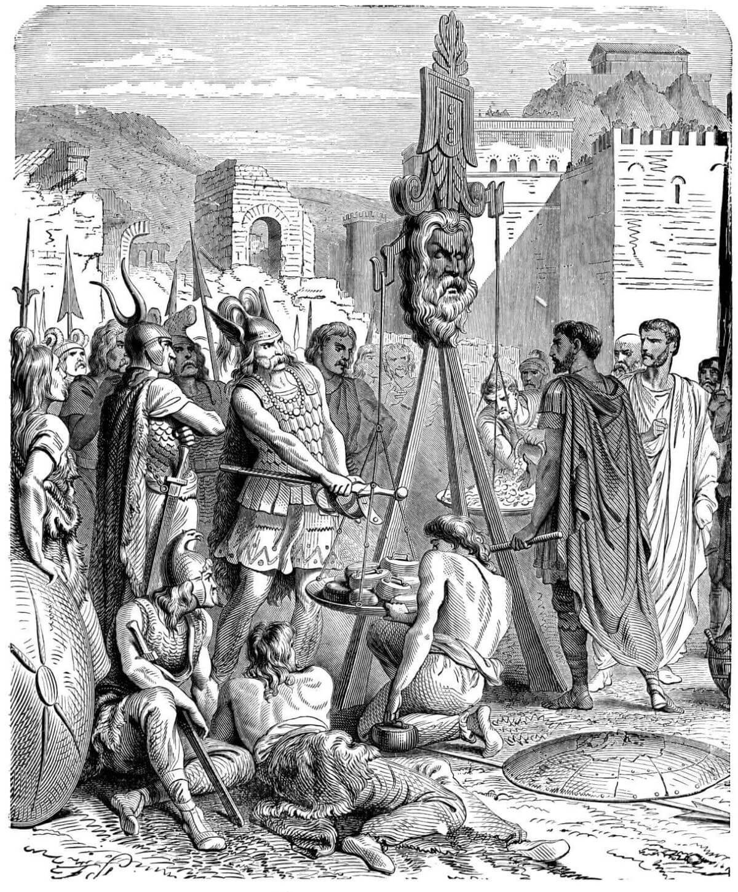
- Illustration of Brennus and Camillus, during the siege of Rome, from "Histoire de France en cent tableaux" by Paul Lehugeur, Paris, 1886.

- With the departure of Brennus and his Gauls, many Romans wanted to abandon their city and move to the nearby city of Veii, but reverence for the gods and a strong desire to not be beaten meant they decided to stay, and quickly rebuilt the city. One major improvement was the completion of the Servian Wall, which was supposedly built by the king Servius Tullus.
- As a further result of the Gallic invasion, the Romans adopted new military weaponry, abandoning the Greek Phalanx-style spears in favor of the gladius and modified armor. The legion was reorganized, placing the youngest and strongest soldiers in the front lines, as opposed to the previous formation of order according to wealth.
- The Gallic invasion left Rome weakened, encouraging several previously subdued Italian tribes to rebel. The Etruscans, Volsci, Hernici, and Aequi were all among these numbers. One by one, over the course of the next fifty years, these tribes were defeated and brought back under Roman dominion.
- Meanwhile, the Gauls would continue to harass the region until 345 BC, when they entered into a formal treaty with Rome. Like most others, this treaty would be short-lived, and the Romans and Gauls would maintain an adversarial relationship for the next several centuries. The Gauls would remain a threat in Italy until the final defeat of Hannibal in the 2nd Punic War.
- The sack of Rome would long be remembered by the Romans, and would finally be avenged three and a half centuries later with Caesar's conquest of Gaul.
- The Gallic Sack of Rome
- Share
- Tweet
- Share
- Pin
- Share
- In the 5th and early 4th centuries BC, migratory Germanic tribes pressured Gallic Celts living in the Danube regions to push south in search of new territory. They were likely familiar with the Po River valley, in north-central Italy, from trade arrangements with Etruscans who were there.
- The Gauls crossed the Alps en masse, capturing and settling Etruscan territory by force. The Gallic tribes were united only by blood and origin, and each maintained their own kings or warlords. Some of these tribes settled into cattle and cereal farming, along with peaceful cohabitation, but others maintained aggressive policies towards their new neighbors.
- One such tribe, the Senones, was under the command of a Brennus, who led his Celts to the Etruscan city of Clusium, about 100 miles north of Rome. It is important to note that much of the ancient source material, such as Livy, Polybius and Diodorus Siculus, is steeped in legend or, especially on the part of Livy, biased though nationalism.
- Brennus, leader of the Senones

- Whether Clusium was the target, or it simply stood in the path on the way to the more powerful city of Rome, is unclear. What is certain, however, is that the Celts did approach and lay siege to Clusium, and that the Etruscans there likely set aside any differences and called to Rome for help.
- In response, according to the ancients, the Romans sent a delegation of three envoys to treat with Brennus. Siculus claims that the three were really spies sent to assess the strength of the Celts, but it is apparent that whatever the reason for the meeting, it escalated into violence.
- After exchanging insults, the Roman envoys were involved in a skirmish with the Gauls, in which one Celtic chieftan was killed. The commissioners returned to Rome without relief for Clusium, and with an angry Gallic army behind them. Brennus sent his own representatives to Rome to demand the three men be turned over to him, but was predictably refused. Later that year, the angered Gauls left Clusium behind and headed for Rome to seek revenge.
- The advancing Gauls invaded Roman territory and threatened the security of Rome itself. Eleven miles to the north of Rome, an outnumbered Roman army mustered under the command of Quintus Sulpicius. The two armies met in July of 387 BC (the traditional date is recorded as 390 BC, but the Varronian chronology is erroneous), and suffered a crushing defeat on the banks of the River Allia.
- As all appeared lost, some Roman defenders retreated to the Capitoline Hill to endure a siege, while civilians fled through the city gates to the city of Veii and the surrounding countryside.
- The Gauls poured into Rome, slaughtering civilians, while looting and burning everything in their path. At some point they apparently attempted an uphill attack on the heavily fortified capital, but were repulsed and never able to dislodge the occupants.
- For seven months the Gauls remained in the area and wreaked havoc around Rome. Several assaults on the city all failed, and one such night attempt was even said to have been thwarted through the timely intervention of the sacred geese of the Temple of Juno, who made a noise when disturbed by the approaching Gauls.
- In any event, by this point the Roman garrison must have been getting dangerously low on supplies. The Romans engaged with Brennus for terms that would ensure that the Celts depart, and Brennus apparently agreed to leave Rome for the price of 1,000 lbs. of gold.
- There are theories that many of the Gauls were becoming ill from from disease, or that their own settlements to the north were under attack by other tribes. Whatever the reason, Brennus agreed to leave when the Romans had accepted the terms. The following passage from Livy, regarding these terms, leaves us with one of the most famous lines accredited to a barbarian chief in dealings with Rome:
"Quintus Sulpicius conferred with the Gallic chieftain Brennus and together they agreed upon the price, one thousand pounds' weight of gold. Insult was added to what was already sufficiently disgraceful, for the weights which the Gauls brought for weighing the metal were heavier than standard, and when the Roman commander objected the insolent barbarian flung his sword into the scale, saying 'Vae Victis-- 'Woe to the vanquished!"
- Illustration of Brennus and Camillus, during the siege of Rome, from "Histoire de France en cent tableaux" by Paul Lehugeur, Paris, 1886.

- With the departure of Brennus and his Gauls, many Romans wanted to abandon their city and move to the nearby city of Veii, but reverence for the gods and a strong desire to not be beaten meant they decided to stay, and quickly rebuilt the city. One major improvement was the completion of the Servian Wall, which was supposedly built by the king Servius Tullus.
- As a further result of the Gallic invasion, the Romans adopted new military weaponry, abandoning the Greek Phalanx-style spears in favor of the gladius and modified armor. The legion was reorganized, placing the youngest and strongest soldiers in the front lines, as opposed to the previous formation of order according to wealth.
- The Gallic invasion left Rome weakened, encouraging several previously subdued Italian tribes to rebel. The Etruscans, Volsci, Hernici, and Aequi were all among these numbers. One by one, over the course of the next fifty years, these tribes were defeated and brought back under Roman dominion.
- Meanwhile, the Gauls would continue to harass the region until 345 BC, when they entered into a formal treaty with Rome. Like most others, this treaty would be short-lived, and the Romans and Gauls would maintain an adversarial relationship for the next several centuries. The Gauls would remain a threat in Italy until the final defeat of Hannibal in the 2nd Punic War.
- The sack of Rome would long be remembered by the Romans, and would finally be avenged three and a half centuries later with Caesar's conquest of Gaul.
- The Samnite Wars
- Share
- Tweet
- Share
- Pin
- Share
- Introduction
- Rome, having survived the invasions of the Celtic Gauls in the early 4th century BC, set its sights on further expansion in the middle part of the century. They re-conquered those Latin and Etruscan towns that had left the fold during the Gallic occupation and, in absorbing others, reconsolidated their position as the dominant force in Latium and Central Italy. With their home turf secured (or so it seemed), the Romans looked south towards Campania.
- At this time, the Samnites had moved into the fertile lands of Campania from the south-central Appenines. They already controlled the towns of Capua and Cumae to the south of Rome, and held sway to the east as well. Rome, to protect its flanks while still in the midst of re-taking Latium and Etruria, wisely entered into an alliance with the Samnites in 354 BC.
- Conflict with Samnium over Campanian dominance was inevitable, however, and would soon turn into a series of wars lasting from 343 - 290 BC.
- 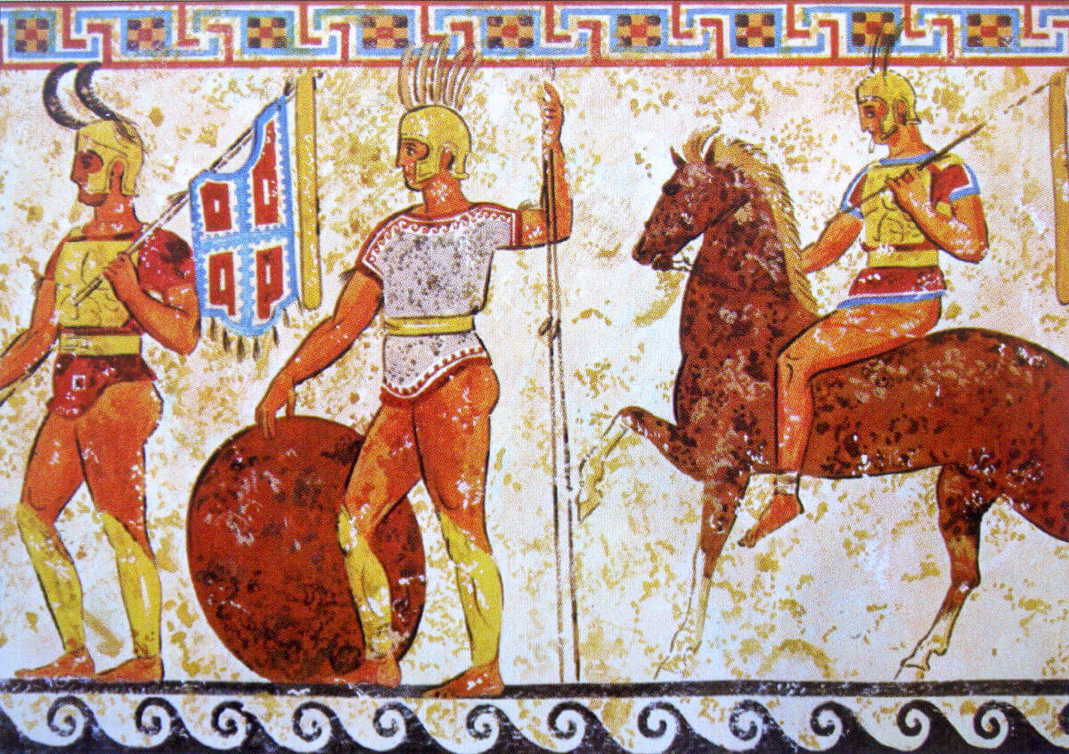
- A painting of Samnite soldiers from a tomb frieze

- The First Samnite War
- In the 340s BC, while Philip II of Macedonia (father of Alexander the Great) was occupied with the Persians to the east, war in Italy broke out on the plains of Campania, near the Greek colony of Neapolis (Naples).
- Philip and the Macedonian armies were occupied with the Persians to the east and various other regional conflicts, while Lucanian and Bruttian tribes were harassing the Greek colonies farther to the east on the Adriatic coast. These colonies called to Epirus for help, while Neapolis, in a more isolated position, had no choice but to call on Rome for assistance.
- The most powerful group of the highland Sabellian people, the Samnites, were invading into Campania and taking territory easily in the middle of the fourth century BC. The warlike Samnites far outmatched their civilized neighbors and found the fertile lands a much better place for herding their animals than the rough hills of the Appenines.
- According to unreliable accounts, Roman envoys, at the behest of Neapolis, went to the Samnites to discuss mutual terms of peace in the region. Their intervention was supposedly rudely rebuffed, and war would be the result.
- The resulting First Samnite War was a brief but consequential affair. While historical accounts, including one by Livy, are rife with untrustworthy depictions, it is safe to assume that the war was marked by Roman victories in the field.
- Despite the successes, trouble again with her Latin neighbors would force Rome to make peace within two years of the onset of war. Angry over conscription into a Roman war outside of their own territory, the Latins revolted once again. Increasingly dependent on Rome, the Latin League saw the Samnite pre-occupation as a perfect opportunity to withdraw from Rome's dominance. In response, the Romans had no choice but to break off their southern conquests and deal with their neighbors once again.
- Despite its brevity, and lack of true historical references, the First Samnite War was a resounding success for Rome. It resulted in the major acquisition of the rich lands of Campania, with its capital of Capua.
- The Campanians, civilized and peaceful, were probably no match for the aggressive Samnites, and an alliance with the powerful young Roman Republic seems a natural occurrence. It illustrates the model of Roman diplomacy in which an alliance results in the absorption of the ally into Rome's dominion.
- Whether through political and diplomatic necessity, or through military intimidation, there is no dispute that Campania became firmly attached to Rome at the end of the First Samnite War. The addition of Campania not only added considerable wealth and territory to the growing power of Rome, but boosted her already sufficient manpower recruiting base for future legionary campaigns.

- The Second Samnite War
- After the end of the Latin War in the 330s BC, the Romans expanded into the territory of the Aurunci and Sidicini, to the south of the Volsci. They also attempted to reassert control of Campania by moving south across the Liris River. In 328 BC the Romans, clearly looking for another fight with Samnium, established a colony at Fregellae on the Liris River.
- The Samnites, of course, found this to be an unacceptable intrusion by Rome, but were too pre-occupied to respond immediately. They were involved in a conflict with the Greek colony of Tarentum and its ally, King Alexander of Epirus. At the end of this war, in 331 BC, the Samnites were free to deal with the reality of Roman expansion.
- The Romans had claimed that the Samnites were encouraging the people of Neapolis to expand into the territories of Campania, which necessitated the creation of colonies in disputed areas. The Samnites, in response, sent troops to garrison Neapolis (the present-day city of Naples), and the elite class called to Rome for help. In 327 BC, a Roman army arrived and threw out the Samnite garrison, setting off the Second Samnite War.
- By the beginning of this renewed war, the Samnites controlled approximately twice as much territory as the Romans, although a lot of it was mostly mountainous and not as fertile. Initially, the war went clearly in the favor of Rome, even prompting Samnium to sue for peace in 321 BC. The Romans, overconfident, offered terms that were so lopsided that the Samnites rejected them, and the war continued. While seemingly in dire straits, the Samnites would learn to use their mountainous terrain to their advantage, and turn the tide of the conflict.
- Later in 321 BC, the two Consuls for that year advanced a Roman army deeper into Samnite territory. The territorially-advantaged Samnites, at what would become the Battle of the Claudine Forks, soon trapped the Romans in a mountain pass. Finding themselves completely surrounded and faced with certain annihilation, the Romans capitulated and were forced to march out under a "yoke of spears". The Romans were forced to give up their spears and march under them, a sign of the ultimate battlefield humiliation.
- Some sources suggest that 600 Equites had to be handed over as hostages, and that the Romans had to agree to a five-year peace treaty, while also giving up her colonies at Fregellae and Cales. Later Roman historians, however, tried to claim that these terms were rejected, but it's quite clear that operations against Samnium did cease until about 316 BC.
- In this five year respite, the Romans took the opportunity to strengthen their military position. In 318 BC, they absorbed two more regional tribes, the Oufentina at the south of Volsci territory, and the Falerna to the north of Capua. They also surrounded the Samnites with Roman allies by attacking and overtaking the Apulia and Lucania to the east and south of Samnium. Several more tribes were forced to take allied status with Rome, further increasing the pressure on the Samnites.
- When military operations resumed in 316 BC, however, Rome still found itself on the losing side of the conflict. They were defeated in several successive engagements, including a crushing defeat at Lautulae in 315 BC. Within a year, Campania was on the verge of rejecting Rome and joining the Samnites, so the Romans were forced to sue for peace again with some of the Samnite factions.
- The Samnites, however, kept the pressure on by encouraging the Etruscans of Etruria to join them. By 311 BC, at the end of a forty-year treaty, the Etruscans joined the conflict, but just at the time the tide was beginning to turn.
- Initially, the Romans were continuously defeated by both of their enemies, but between 311 and 304 BC they won a series of victories against both the Etruscans and the Samnites. In 308 BC, the Etruscans were forced to capitulate on severe terms, and in 304 BC the Samnites followed suit. While not conquered, the Samnites were severely weakened and Rome, despite the struggle, came to take considerable territory and establish many new colonies.
- In addition to this gain of territory, some ancient sources suggest that the Romans adopted the manipular military formation of the Samnites after witnessing their early successes. It was far more flexible than the hoplite system of the Greeks and Etruscans that Rome had been using, and allowed great maneuverability on all sorts of terrain and conditions. The system was in use throughout the period of the Republic, and later evolved into the cohort formation of the Roman legions that would later conquer Europe.
- The Second Samnite War is a perfect example of Rome's long-range campaign tactics, and how planning for the long term would nearly always pay off. As a result of this strategy, the construction of the Via Appia road (by Censor Appius Claudius) was begun in 312 BC, and the Via Valeria in 306 BC. The Via Appia covered the 132 miles between Rome and Capua in Campania, and provided a fast moving highway for the early legions to advance against the Samnites. The first of many remarkable Roman engineering achievements, this Roman road - literally - paved the way for the conquest of Southern Italy.
- This final decade of the fourth century BC was the culmination of resistance to Roman domination by several neighbors. The Aequi and Hernici both revolted and joined the Samnites. Several other previously unmolested tribes - the Marsi, Marrucini, Paeligni, Frentani and Vestini - also joined Samnium against Rome.
- Even so, their efforts were too late to stop the spread of Roman expansion, and in 305 BC a Roman victory led the Paeligni and Hernici to surrender. In 304 BC, the Aequi were defeated in the same year the Samnites sued for peace, and all of the other tribes of Central Italy would make alliances with Rome within another two years.
- The Samnites were still a thorn in Rome's side, however, and conflict would be renewed within the decade.

- The Third Samnite War
- At the close of the century in 298 BC, after only six years of peace, the Romans again found themselves at odds with the Samnites. Old wounds were slow to heal, and the Samnites decided that intervention was still necessary to stop the Roman spread of power.
- The Third Samnite War became the last desperate attempt of the Samnites to remain independent, and they were able to convince Rome's old enemies to join together against them once again. The Etruscans, the Umbrians, the Gauls, and other regional tribes joined in arms with Samnium in an attempt to check Rome's ever increasing regional authority.
- The war began again near Neapolis, where possession of the plains of Campania had been a constant source of conflict. The threat to Rome was very real, facing newly coordinated enemies from all sides; the Samnites to the south and east, and the Etruscans and Gauls to the north.
- Until now, Rome had mostly been able to stand against single enemies at a time, but unification of these old foes made the challenge more difficult. This coalition of states not only created challenges, but highlighted the desperation of these tribes to reverse Roman expansion.
- Early in the conflict, Rome shattered a Samnite army in the south, allowing attention to be focused on the Etruscans and Gauls in the north. The pivotal battle for Italy took place in 295 BC at Sentinum in Umbria, where, according to various sources, more combatants were engaged in a single encounter than at any time previously in Italy.
- Chariot driving Celtic Gauls forced the Romans back initially, but Roman military discipline soon commanded the field, crushing the coalition against them. The Samnites, despite their less than favorable results, still managed to hold out for five more years, finally capitulating in 290 BC.
- Rome granted Samnium a favorable treaty, forcing them into an alliance and ending their unified resistance for the remainder of Rome's history. The Campanian cities - both Italian and Greek - including Capua and almost all others, were now the undisputed allies of Rome, with varying degrees of independence. The Sabines ceded territory as well, and several Roman colonies (13 known in total) were settled in Campania, as well as on the eastern outskirts of Samnium.
- The years surrounding the Samnite Wars were not only one of military prowess for Rome, but of great public works as well. In 329 BC, the Circus Maximus got one of many face-lifts throughout its history, gaining permanent horse-stalls and starting gates. As mentioned, the first major Roman road, the Via Appia, was constructed from Rome to Capua in 312 BC, and the first Roman aqueduct, the Aqua Appia, was also established at the same time.
- These magnificent structures not only were of great benefit to Rome and her population, but proved the flourishing status of the state even during a time of war and expansion.
- At the end of the Samnite Wars, Rome held perhaps as many as 150,000 people, making it one of the largest cities in the Mediterranean region. As many as 1,000,000 people claimed citizenship to Rome, and vastly larger numbers were obligated through Latin rights and allied status.
- With the defeat of Samnium, the last major Italian threat, Rome was the master of nearly the entire Italian peninsula, save for the Gauls occupying the Po valley in the north, and the Greek holdout cities like Tarentum in the far south. This growing power soon gained the attention of regional powers in Greece and later, the masters of the Mediterranean, the Carthaginians (Related Page: The Punic Wars and Roman Expansion).
- Did you know...
The language of the Samnites was called Oscan. A relative of Latin, it was the dominant language of Italy from around 500 BC until the spread of Latin with the Roman conquest.
- Did you know...
Livy is our primary source for the entire conflict with Samnium. Although he describes the wars and battles with enthusiasm and detail, the historical accuracy of much of the account remains suspect.
- Did you know...
The Umbrians were Italic people of Indo-European roots. They built associations and large polygonal walls to defend their villages. These irregular shapes of stone walls can still be seen today in the Umbrian towns of Spoleto, Amelia, Todi and Narni.

- The Latin War and Revolt
- Share
- Tweet
- Share
- Pin
- Share
- Since the Gallic sack of Rome in the early 4th century BC, Rome had became increasingly dominant within Latium and among her Latin neighbors. With the end of the First Samnite War, the Romans had taken control of Campania, and the people there gladly entered into an alliance with Rome.
- 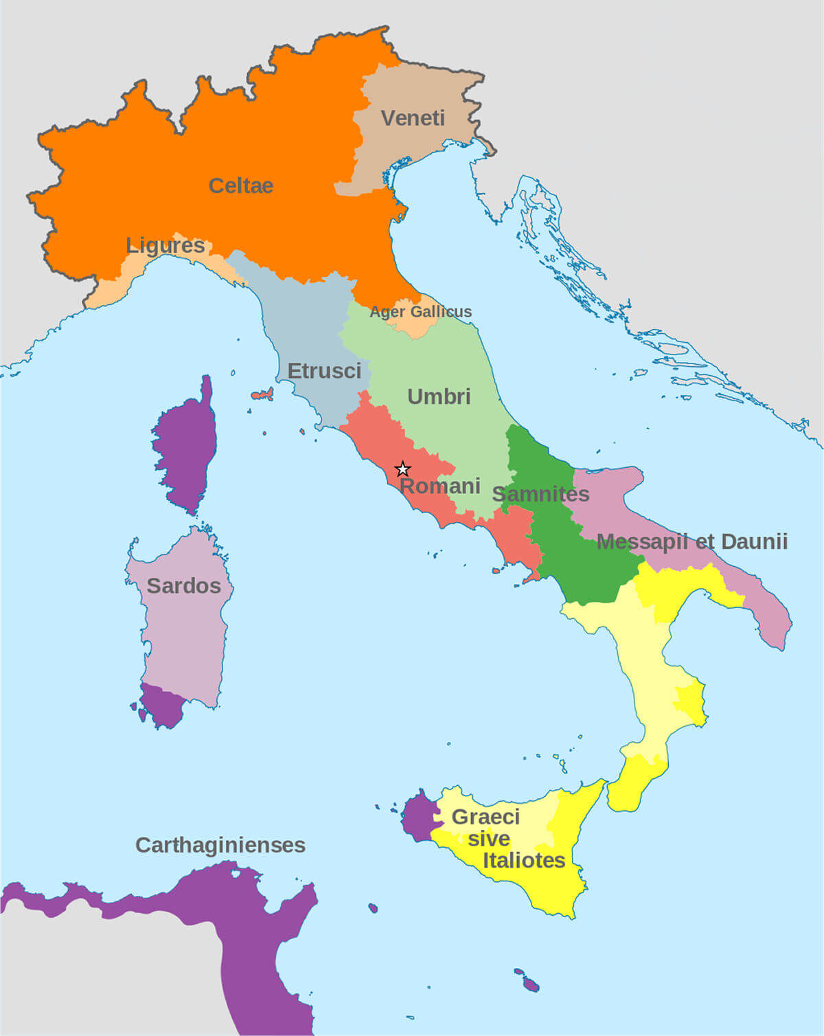
Halibutt, CC BY-SA 4.0, via Wikimedia Commons
- A map of Italy in the 4th century BC, showing various tribe confederations/alliances/groups in the wake of the Latin War. Borders are approximate. For clarity the northern border of modern Italy is marked, in reality the Celtic tribes extended way beyond that line.

- The Latins, having fully aided Rome in the war, expected equal treatment in regard to the spoils, and therefore continued to harass the Samnites despite overtures towards peace by Rome. The Latins and the Campanians both feared Rome's rising power, and that their allied relationships were really relationships of domination.
- While the Latins continued action against the Samnites, they asked Rome to intervene on their behalf and stop the fighting. The Latin League would view this as a continued effort to dominate, and an already shaky relationship would only worsen. The Latins demanded equal status among all the league members, and a share of the governing of Rome which was, unsurprisingly, rejected.
- Campania and Capua joined with the Latins in an open revolt which came to be called the Latin War, while Rome's recent and future enemy, the Samnites, sided with Rome.
- In 340 BC, the Latin War opened with an overwhelming victory for Rome. Under the command of Consul Titus Manlius Imperiosus Torquatus, Roman Republic legions - along with Samnite support - crushed the Latins and Campanians at the Battle of Trifanum.
- The Campanians immediately capitulated and fell back into Roman control, while two years of bitter fighting would be needed to stamp out Latin resistance. In 338 BC, Rome dismantled the Latin League and came to terms with her neighbors, offering considerable rights while increasing her own authority.
- With Roman victory, some of the Latin city-states were fully incorporated within the Republic, while others were given rights to lesser Roman citizenship. Commercium, the right to conduct business with Rome, and Connubium, or the right to inter-marry between tribes, were two of these rights granted, but were limited to interaction with Rome and not between each other. The making of alliances was reserved only for Rome, and the city-states lost any sort of autonomy in this respect.
- The right of civitas sine suffragio, citizenship without the right to vote in the popular assemblies, would become the standard Romanization policy that would build the Empire.
- The Latin rights, or ius Latii, were a stepping stone for newly-absorbed communities to feel a part of Rome, while being required to show their acceptance of Roman rule before gaining full citizenship.
- In most cases, while each city state was granted various additional benefits or denied rights, depending on the circumstances, the Latin cities no longer had to pay taxes, but instead were required to provide men for the legions.
- Most cities were allowed to keep their governing system under the control of the same elite classes, only under the supervision of Rome.
- The general effect of the Latin War was to strengthen Rome's grip upon Latium and the Italian peninsula, and to provide more lands upon which to settle. Rome now truly dominated all the Latins, and rather than acting as the most powerful member of an alliance, it became a centralized government.
- The next couple of centuries would continue to see revolts by Italian communities, either over social class or various other issues, but with the elimination of the Latin League, Rome truly became the master of central Italy.

- The Pyrrhic War
- Share
- Tweet
- Share
- Pin
- Share
- With the conclusion of the Samnite Wars, Rome had consolidated its position as master of central Italy. With its rising power in the Mediterranean, conflict with the Greek city-states (Magna Graecia) of southern Italy was inevitable.
- The Lucanians and Bruttians, in the early 3rd Century BC, continued attacks on these Greek colonies and they, in 283 BC, appealed to the Roman regional power for help.
- The most influential city of Magna Graecia at the time was Tarentum. Its position in south eastern Italy made it an important hub for Mediterranean Sea trade, and also isolated it from Roman naval activity on the Tryrrhenum Sea, between Rome and the islands of Corsica and Sardinia.
- Due to its position, and relationship with Greece, Tarentum possessed the most powerful navy of any Italian city at the time, and a standing treaty with Rome had been in place since 302 BC. This treaty denied access to Roman fleets into the bay of Tarantum (in Italy's heel), assuring the autonomy of the Greek navy.
- Heeding the call for aid from regional city-states such as Locri, Rhegim, Croton and Thurii against the Lucanians, Rome sent troops by way of sea to garrison the town of Thurii in 282 BC.
- Despite the call for aid, Tarentum considered this a breach of the treaty and a hostile act of aggression. Tarentum's immediate reaction was to sink the Roman fleet and expel the garrison from Thurii.
- In response, the Roman Senate sent an embassy to Tarentum under Lucius Postumius Megellus to demand amends. During the exchange, the Romans seem to have been insulted (a recurring theme in the histories of Livy and Polybius to justify Roman aggression) and Rome declared war.
- Tarentum, unable to defuse the situation mustered their own army and began creating trouble among the Greek cities and other Roman interests. Fearing Roman retaliation, Tarentum soon turned to King Pyrrhus of Epirus for assistance.
- Pyrrhus, a distant relative of Alexander the Great, envisioned himself as another Alexander. Having recently confirmed his authority through war in Epirus, he anxiously looked to Italy for expansion and glory. The fertile soil of Sicily (according to Plutarch), rather than Italy, was probably the real objective, but the excuse to do battle with the fledgling power of Rome was too good to pass up.
- 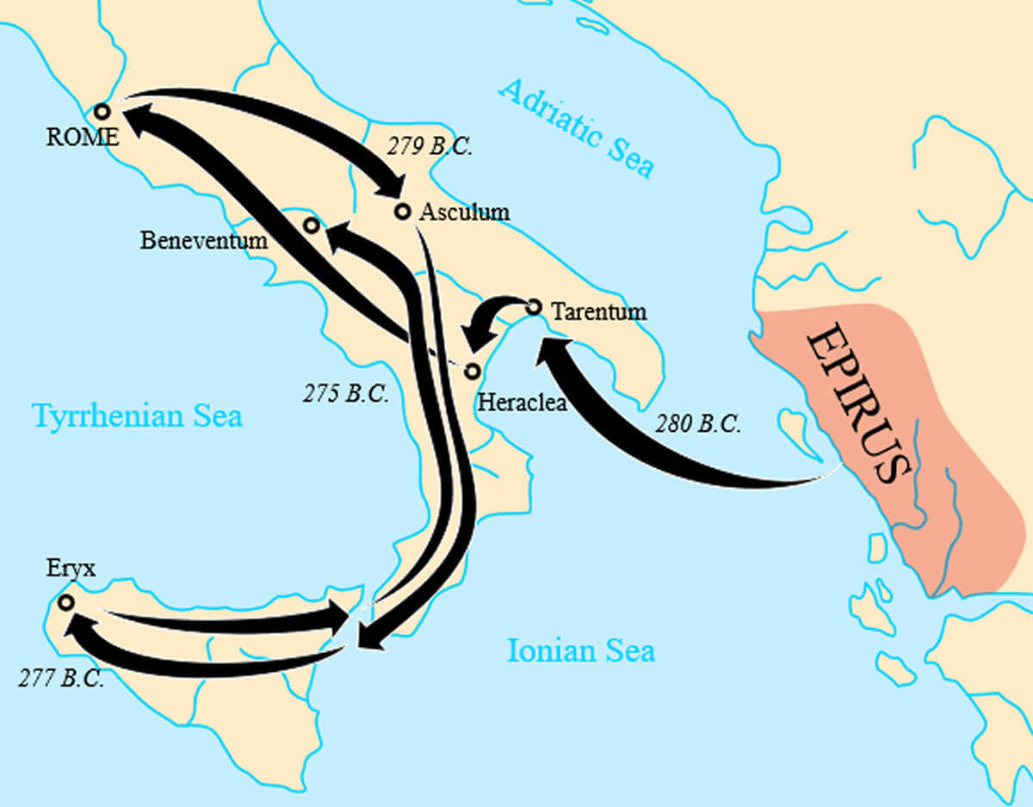
Piom, translation by Pamela Butler, CC BY-SA 3.0, via Wikimedia Commons
- The route of Pyrrhus of Epirus during his campaigns in southern Italy and Sicily.

- The post-Alexander Macedonian kingdoms maintained the most modern and well-equipped armies of the time, and the Epirotes were far more advanced than their Roman counterparts. Using his own forces and those pledged from other regional Greek Kings, on the understanding that they would be used abroad, Pyrrhus took up the challenge from Tarentum and sailed across the Adriatic.
- In 280 BC, the Epirotes landed in Italy with 25,000 men, including 3,000 cavalry and 2,000 archers. Also, shocking to the Romans, Pyrrhus brought 20-war trained elephants along, the first time that the Italian people had seen them. Knowing the devastation they had caused among the Persians under Alexander, Pyrrhus thought that the Italian invasion was the perfect opportunity to emulate that success.
- The Romans, however, had no intention of giving up their regional authority and prepared to fight. They may have been encouraged by surrounding Greek cities, who expressed no interest in Pyrrhus' interference, but regardless, the war was on.
- The first engagement of the war took place at the small coastal town of Heraclea. The Romans, under Publius Laverius Laevinius, with 50,000 men, had driven into Lucanian territory to prevent them from joining Pyrrhus.
- When the battle was joined, the match was fairly evenly fought. The Epirotes would eventually use their elephants to drive through the Roman lines, creating panic and driving cavalry back upon its own troops.
- The Pyrrhic forces advanced and the Roman army may have been destroyed, save for the timely intervention of a wounded elephant that caused panic among the others. The elephants turned on Pyrrhus' own troops and he was forced to call off the pursuit of the Romans to preserve his own army.
- In the end, ancient writers suggest that the Romans lost between 7,000 and 15,000 men, but that the Epirotes lost between 4,000 and 13,000 men accordingly.
- Though the Romans technically lost the battle at Heraclea, Pyrrhus' losses were substantial. An invading army could not endure such terrible losses while outnumbered, and he would have to retire for the season to wait for reinforcements. This condition of victory, with terrible casualties, would become a recurring theme throughout the campaign.
- Pyrrhus had hoped that his invasion would lead to rebellion from Rome's traditional enemies, such as the Latins. He was counting on the support of these people in his efforts. However, by this time, the old rebellious attitudes had mostly subsided, and only some Samnites and the Lucanians joined with Pyrrhus.
- This is significant in that it shows the stabilization that was growing in accordance with Rome's power. These old allies/enemies were now firmly entrenched as members of the Roman Republic, and the changing tides of conflicts no longer had such an overwhelming effect as they had in the past. Additionally, Pyrrhus' treatment of his allies among the Greek cities in southern Italy would also turn their attitudes against him.
- The next year, 279 BC, saw the second major conflict at the battle of Ausculum. A massive engagement (in terms of ancient armies) was fought over two days among the woods and hills of Apulia.
- The Romans, led by Publius Dentius Mus, used terrain to their advantage to reduce the effect of the Epirote cavalry and elephants. The first day would end in a virtual draw.
- As at Heraclea, the second day's fighting was again a stalemate situation until the elephants could be brought to the front. The Romans attempted using ox-drawn war wagons to subvert the elephants, but supporting infantry soon overwhelmed the defense and the Romans had to withdraw.
- At the end of the battle, estimates of 6,000 Roman and 3,500 Epirote casualties left Pyrrhus in command of the field, but again at great cost.
- It is the result of Ausculum where the term "Pyrrhic Victory" is attributed. According to Plutarch, when congratulated on his victory, Pyrrhus replied "that one other such (victory) would utterly undo him."
- Pyrrhus, acknowledging his costly 'victories', offered peace terms to Rome, but was refused as long as he remained in Italy.
- Appius Claudius, a former consul and commissioner of the Appian Way (one of ancient Rome's most famous roads, running from the city of Rome to southern Italy), encouraged the Senate to refuse the simple terms of independence for Tarentum and the southern Greek cities.
- Instead, Rome negotiated an alliance with Carthage, who also had reason to be concerned over Pyrrhic activities in Sicily.
- Pyrrhus, originally hoping to turn Rome and Carthage against one another, found himself the target of both state's animosity. Under pressure from a Carthaginian fleet and with no hope of converting Roman Italian allies, he left for Sicily to protect his interests there.
- In 278 BC he sailed to Sicily to defend the Greek cities on the island. The Carthaginians, however, were already on the move and were besieging Syracuse, his logistical base, as Pyrrhus arrived.
- The powerful Carthaginian fleet was scouring the sea to find him, but he managed to evade capture and eventually defeat the Carthaginian army. Pyrrhus captured the cities of Panormus and Eryx, but Carthage refused his offer of peace in fear that they would lose Sardinia.
- Meanwhile, on the Italian mainland, Rome was pressing hard against Tarentum and the situation was going badly for the Greeks. Pyrrhus had sustained heavy losses in Sicilia, as well, and he feared entrapment by two hostile forces on Sicily. In a final desperate gesture, he would return to Italy for one more campaign.
- He returned to Italy in 275 BC and faced the Romans at the town of Malventum in southern Italy. This time there was not even a 'Pyrrhic Victory" and the Epirotes, defeated, retreated to Tarentum.
- The Romans had learned to deal with war elephants by attacking their sides with spears, a tactic that not only stopped Pyrrhus, but would eventually play a key role against Carthage.
- Several years after the battle, the Romans renamed Malventum to Beneventum (Good Omen) in recognition of their victory, and before long the Appian Way would connect the town to Rome.
- Pyrrhus left Italy shortly after and returned to Epirus. By the end of his campaigns, he returned without the bulk of his army or gains in Italy, and having lost his holdings in Sicily. Again according to Plutarch, his parting words upon returning home, "What a battlefield I am leaving for Carthage and Rome", was a premonition of events to come that would end up shaking the power structure of the Mediterranean, and the western world.
- With Pyrrhus gone, Tarentum, and any other remaining Greek cities, accepted Rome's usual lenient offer of peace to a defeated foe. The city was allowed self-rule under a Roman garrison and appropriate Latin laws, while the other city-states and remaining Italian tribes surrendered in kind.
- By 272 BC, Rome was now the confirmed master of the Italian peninsula, despite some thoughts among the Greeks that they may have been allies rather than subjects.
- With this consolidation, the Conquest of Italy was complete, save for the Gauls in the far north. The Macedonian ruler of Egypt, Ptolemy II, confirmed Rome's power by opening a permanent embassy between the two nations. Roman colonies were founded all over Italy, strengthening and affirming Rome's rule.
- In the end, the victory in the Pyrrhic war not only gained Rome all of Italy, but showed that the Roman ability to adapt and change was mightier than any force in the region. The Greek Phalanx and its static formation would lose its dominance, and be replaced by the adaptable and mighty legions of Rome.
- With Pyrrhus out of the way, and the clash between Carthage and Rome looming, the Romans knew that their greatest strength was perseverance. No matter the cost or effort, and despite defeats and setbacks, they wouldn't stop expanding for over half a millennium.
- As for Pyrrhus, he returned to Epirus with his head held high. If nothing else he was a grand adventurer, and considered later, by Hannibal, to be among the greatest generals in history.
- Despite the near total destruction of his army at the hands of Rome and Carthage, he enlisted Gallic allies to invade Macedonia. Plundering as he went, he set his eyes on Sparta and then Argos, as well.
- Plutarch tell us that while fighting in the streets of Argos, in 272 BC (the same year as the final defeat of Tarentum) an old woman threw a tile down from her roof, and it happened to hit Pyrrhus on the neck. Stunned, Pyrrhus fell off his horse, and an Argosian soldier cut off his head.

